**Goal: Design a heuristic optimized for the bird, and try to beat it controlling the larva. Find the AI’s weakness and refine the heuristic**

L’s strategy is to lure up the birds and pass them

B’s strategy is to move up each piece to make an impenetrable wall until L is cornered. If executed correctly, I don’t even see how L can possibly win.

In a situation where the larva is 2 spaces above a bird, the bird doesn’t want to move.

Each bird will always be separated by at most 2 rows. Always move the bird in the lower row who is farther from the larva. I have yet to find a way for the larva to win against such a strategy.

The movement of the birds alternates between rows

Odd rows: Birds move right

Even rows: Birds move left

L moving up-left and down-right seems to undermine your bird strategy

In general, L alternating moves and generally staying close to the goal seems to be an optimal strategy. In fact, L’s strategy might be to aim for states where a bird is down-left and down-right of him

L is actually at an advantage when making the birds try to corner him -> can pass over it and the birds are helpless to stop him (since they can’t move backwards)

There’s actually a lot L can do to gain an advantage. Basically lure out birds into bad positions and create a path for himself that the birds cannot stop due to no backwards movement.

The bird’s advancing wall strategy completely fails if the larva alternates until there’s an opening

**L’s winning strategy: Always move to the lowest row possible and as close to the middle of the board as possible**

Interesting board configuration

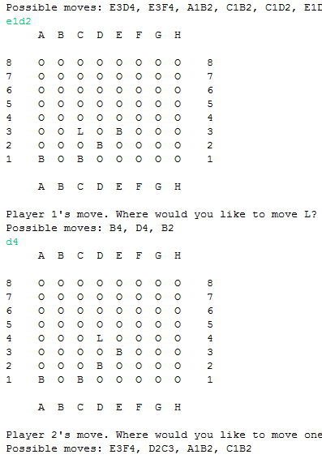

Interesting board setup: Cornering strategy:

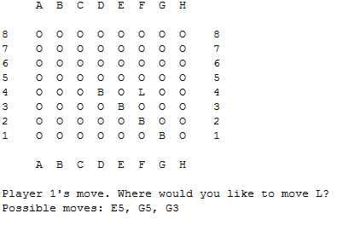

In the following board, which move is better, B2C3 or H2G3?

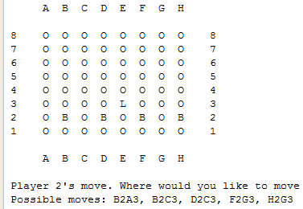

Another interesting board configuration

